**Bash Shell Scripts**

## Accessing the AWS Management Console

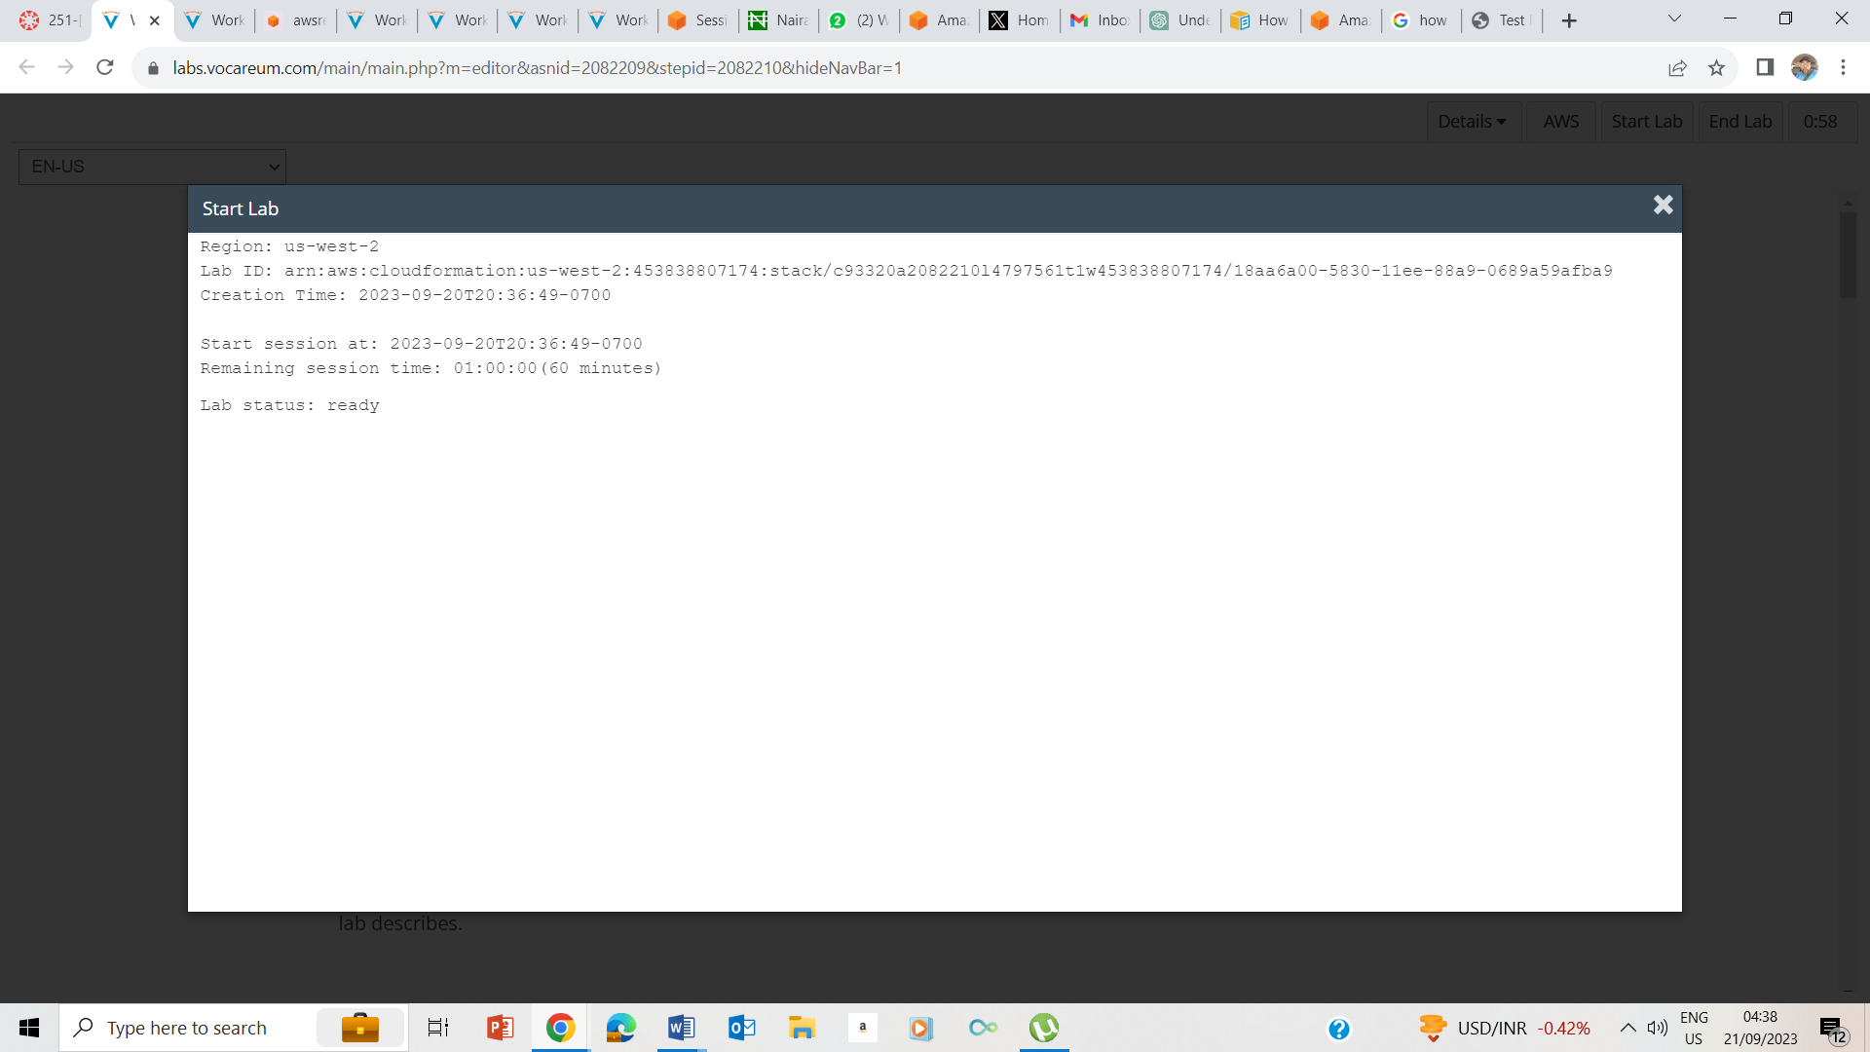

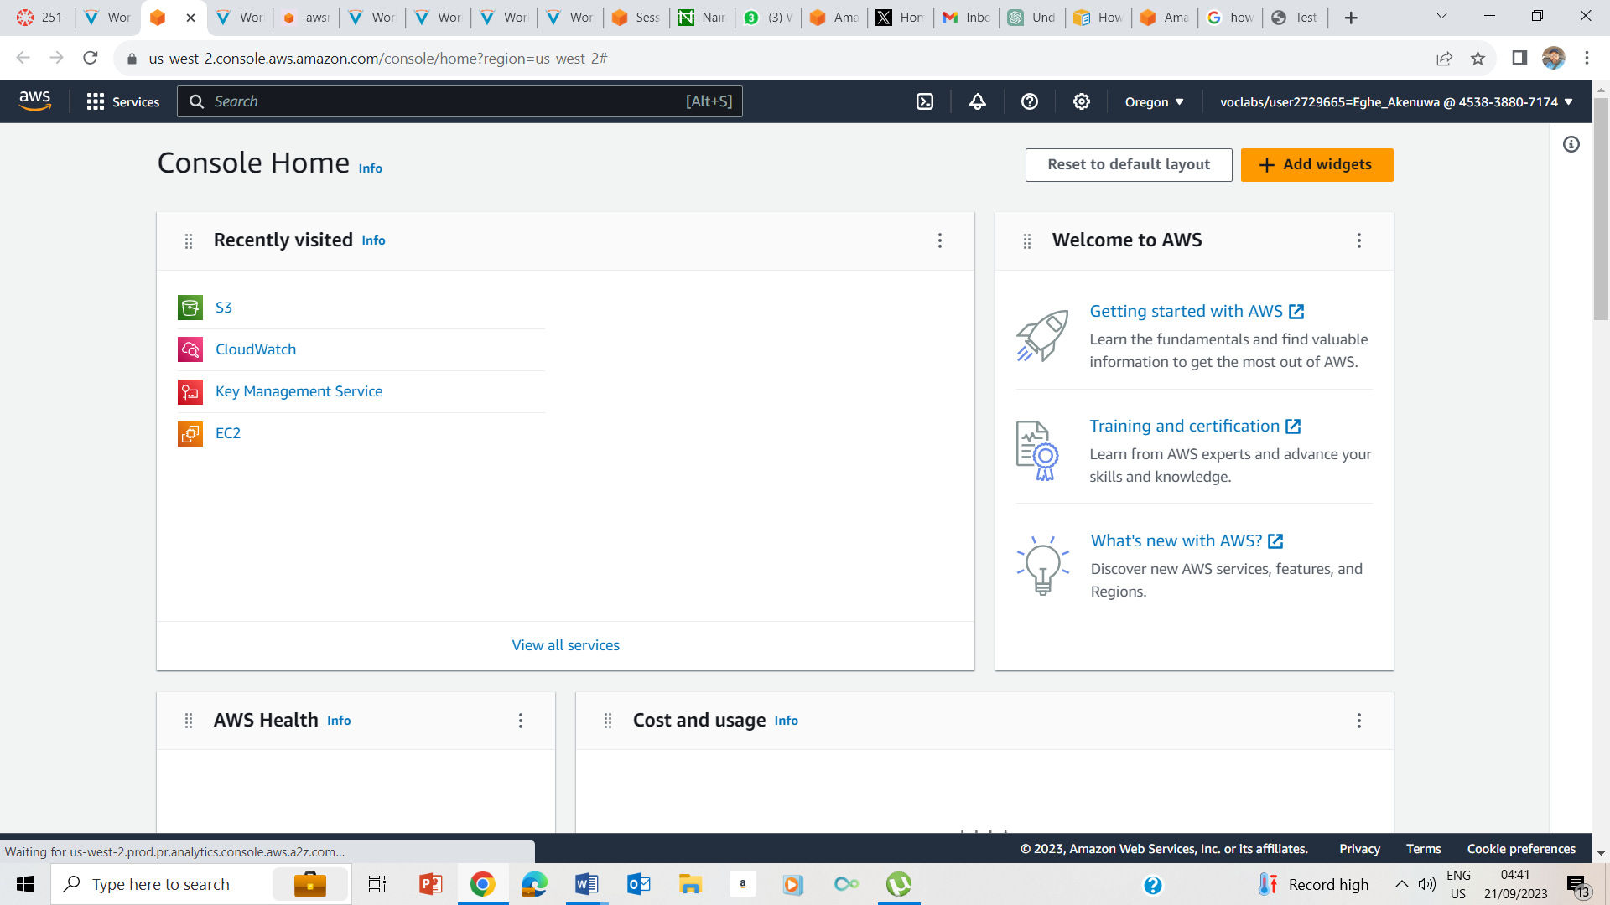

1-4. Pressed Start, waited for it to tell me it is ready, and pressed the AWS button.

## Task 1: Use SSH to connect to an Amazon Linux EC2 instance

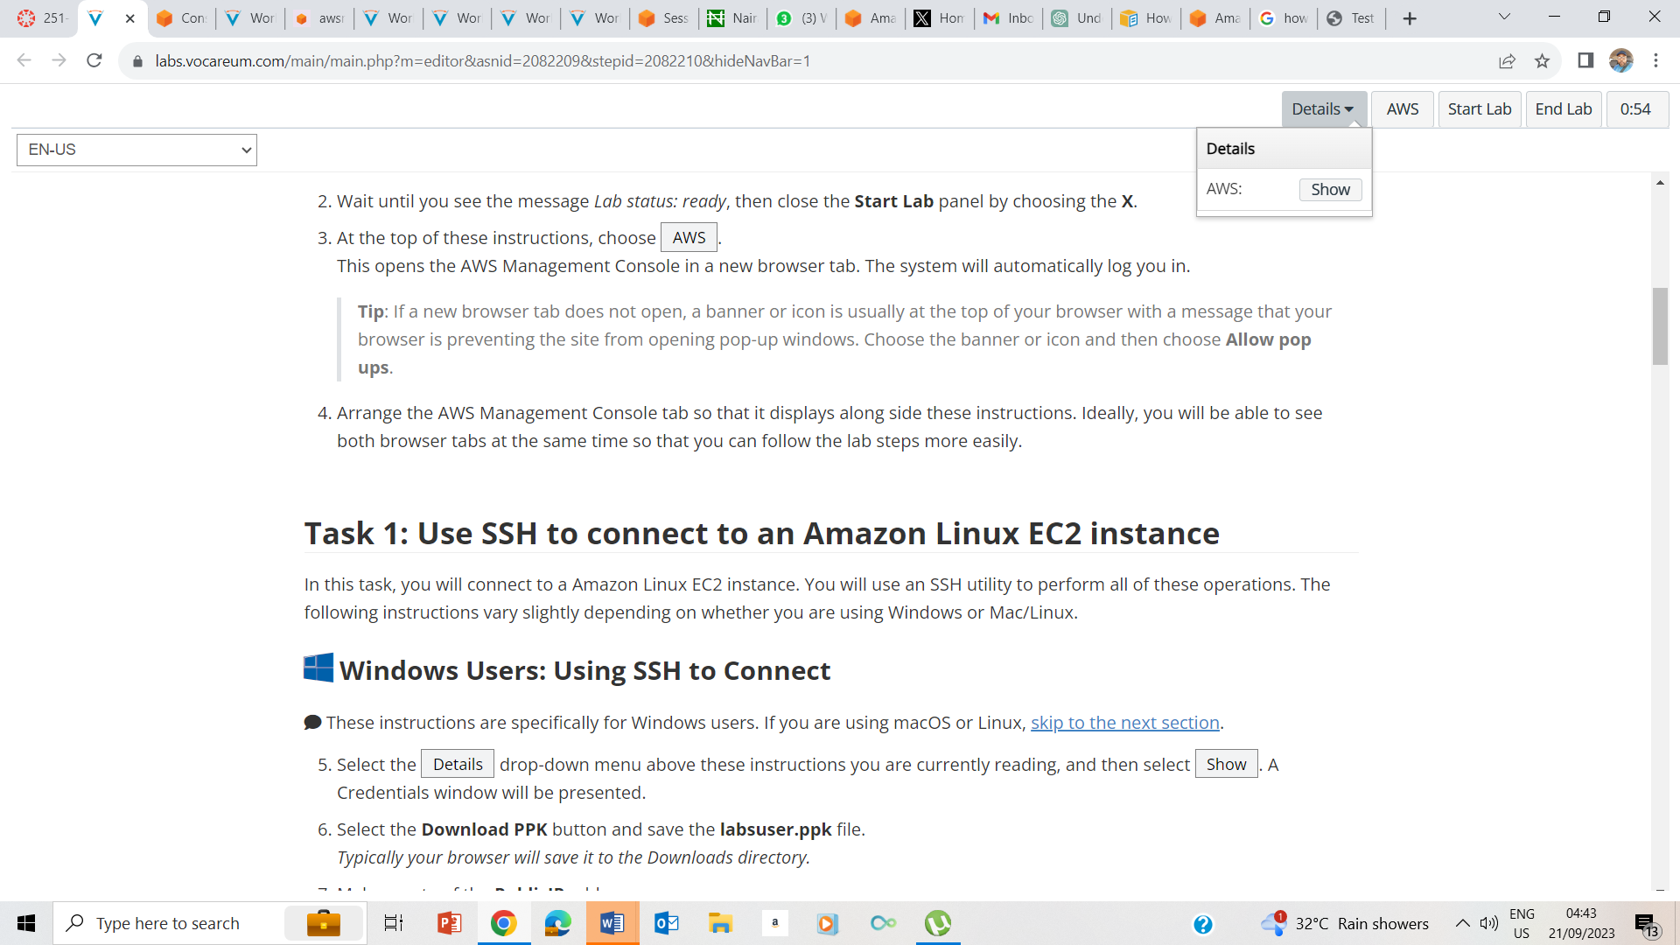

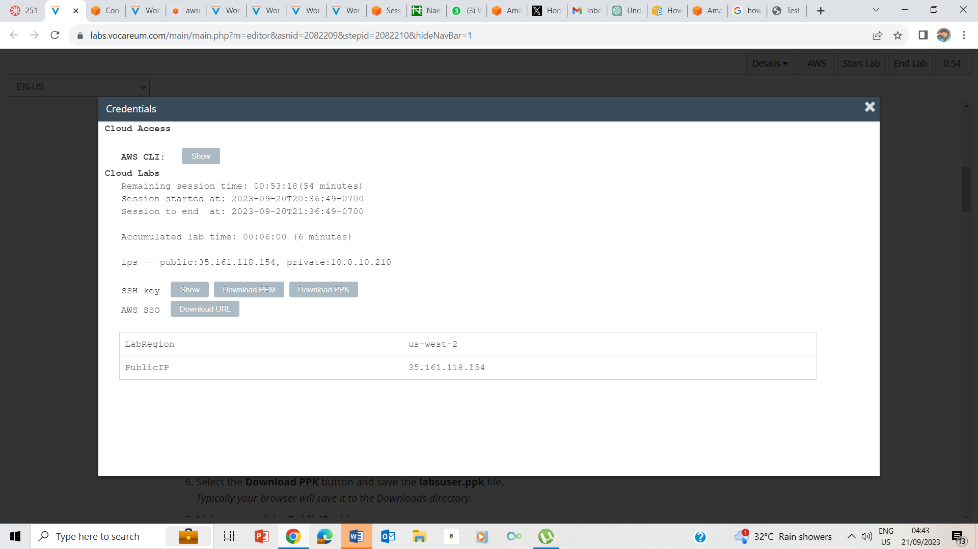

5-7. Clicked on the Details dropdown box, and clicked show button. I also downloaded the PPK file as well as noting the Public IP address as 35.161.118.154

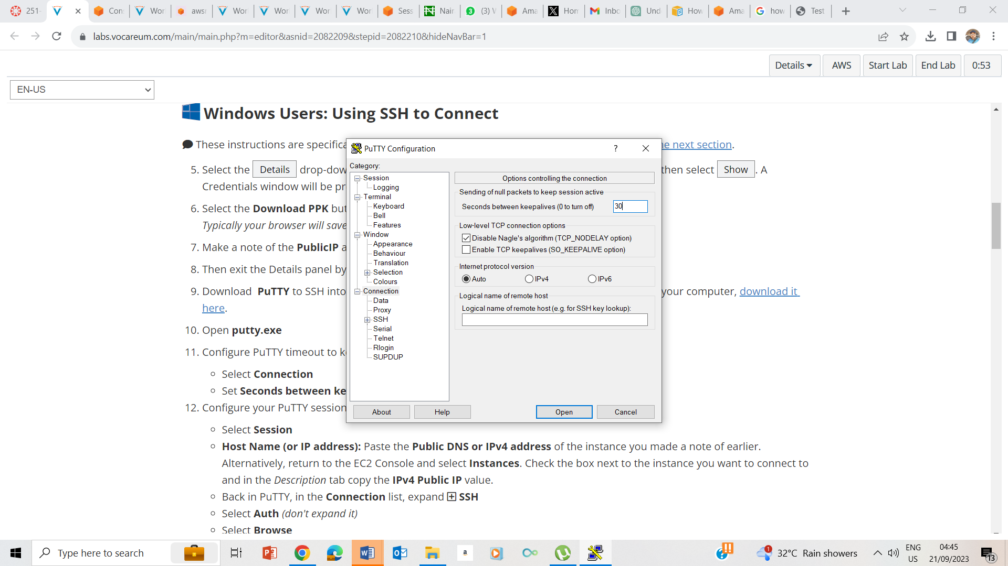

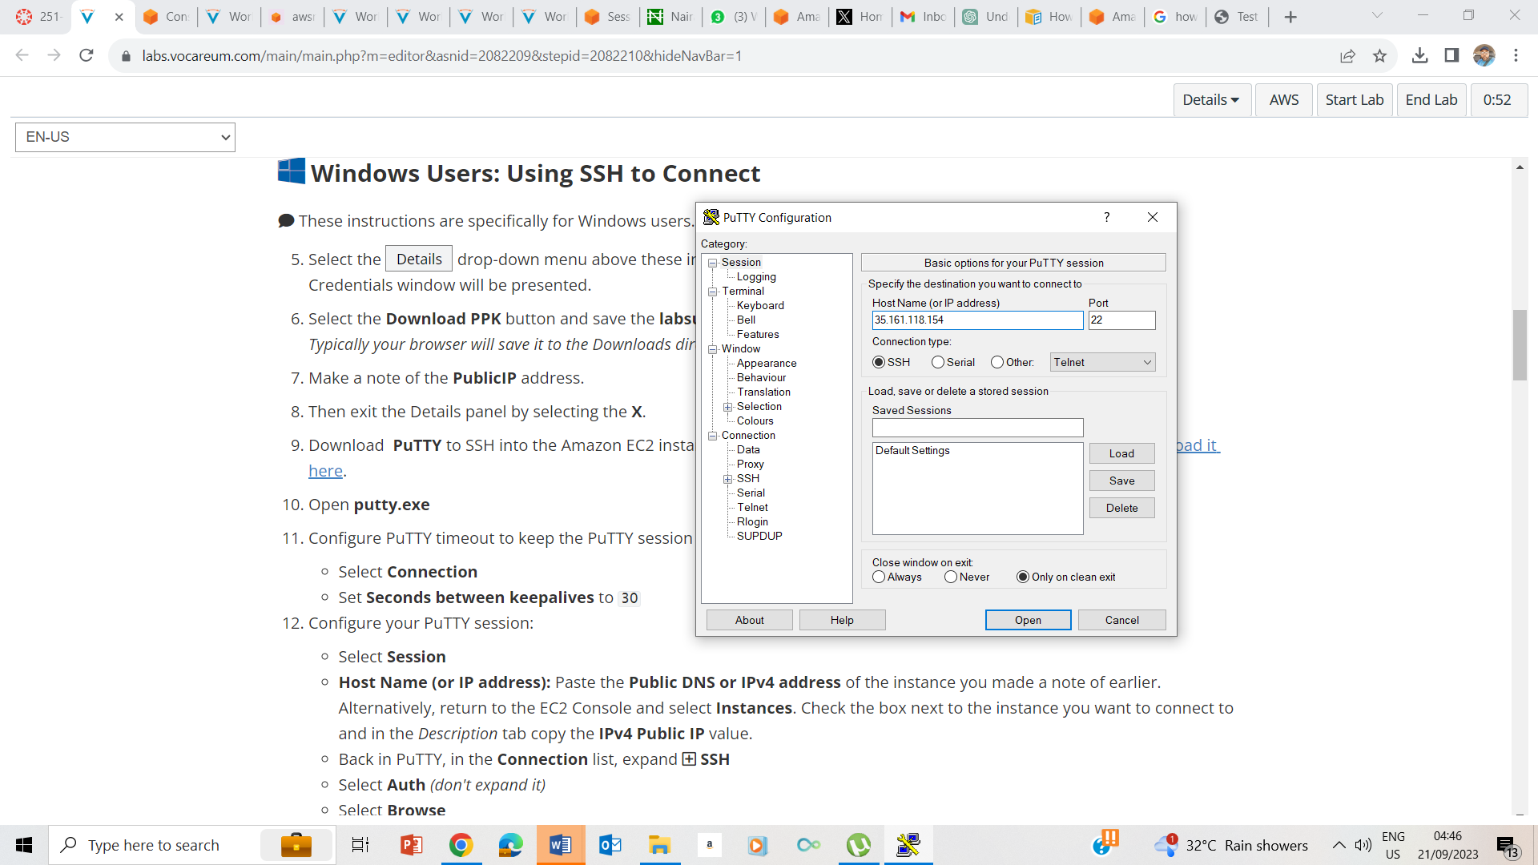

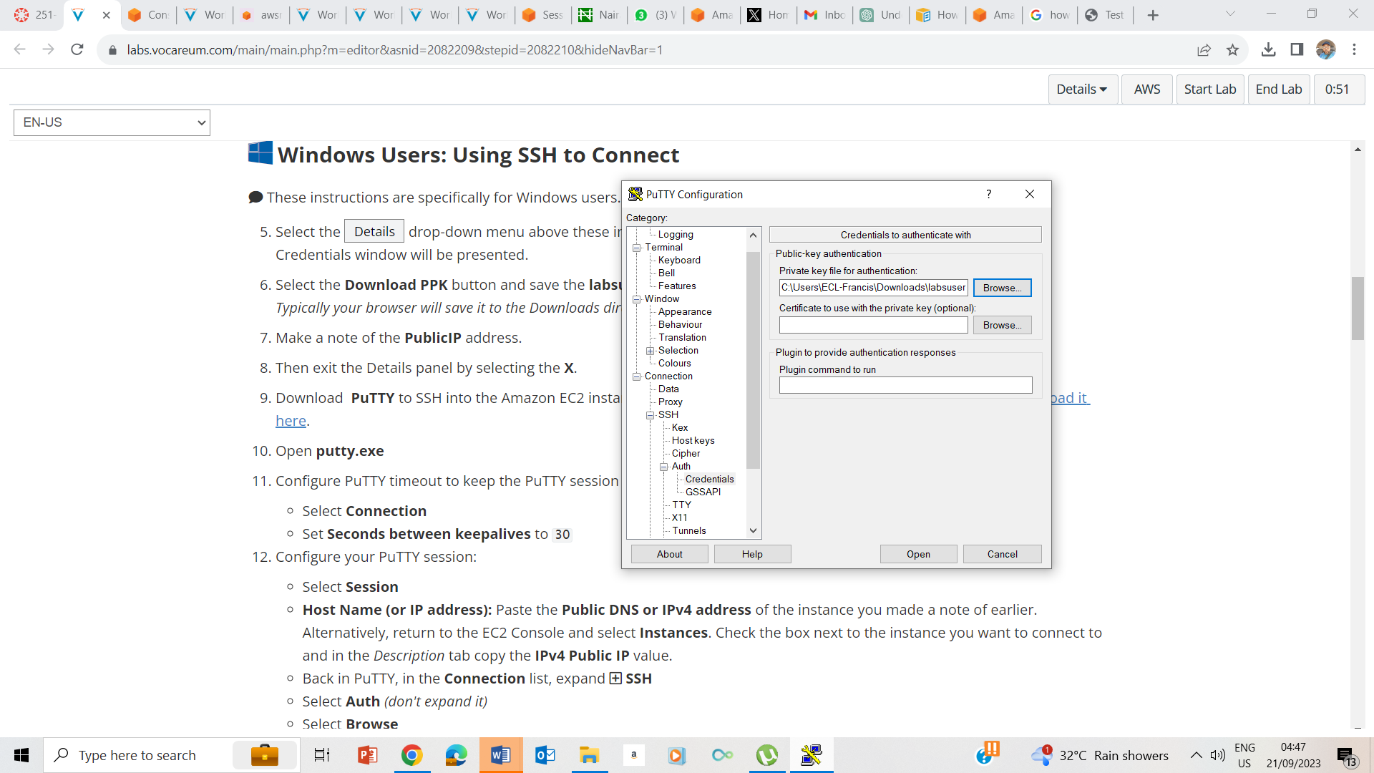

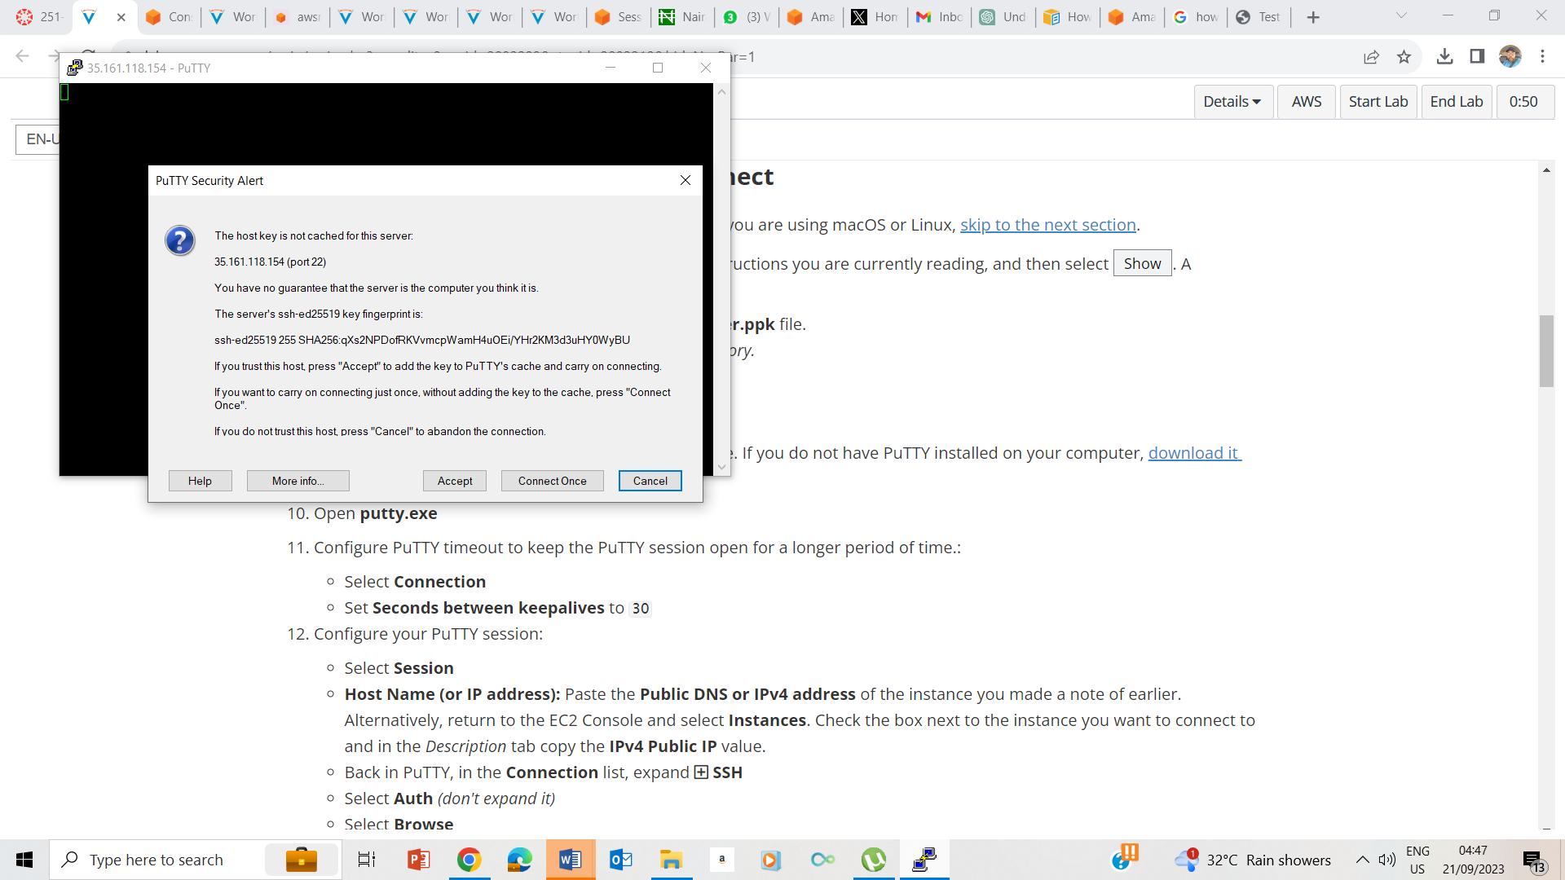

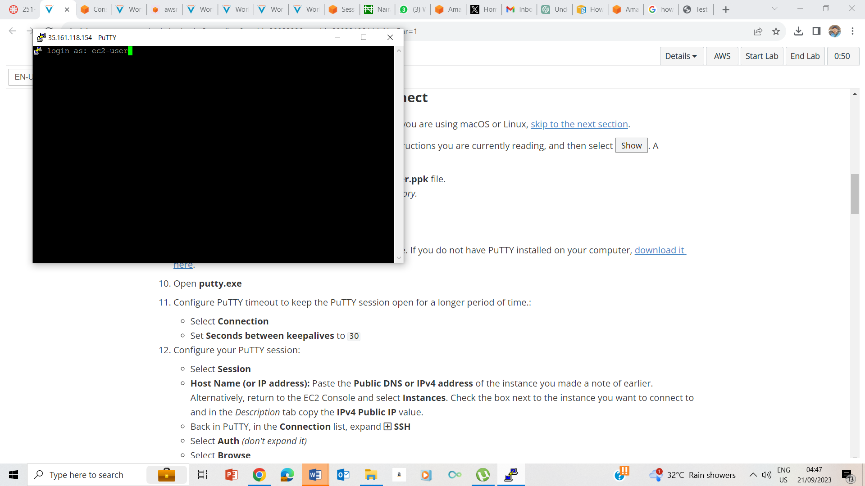

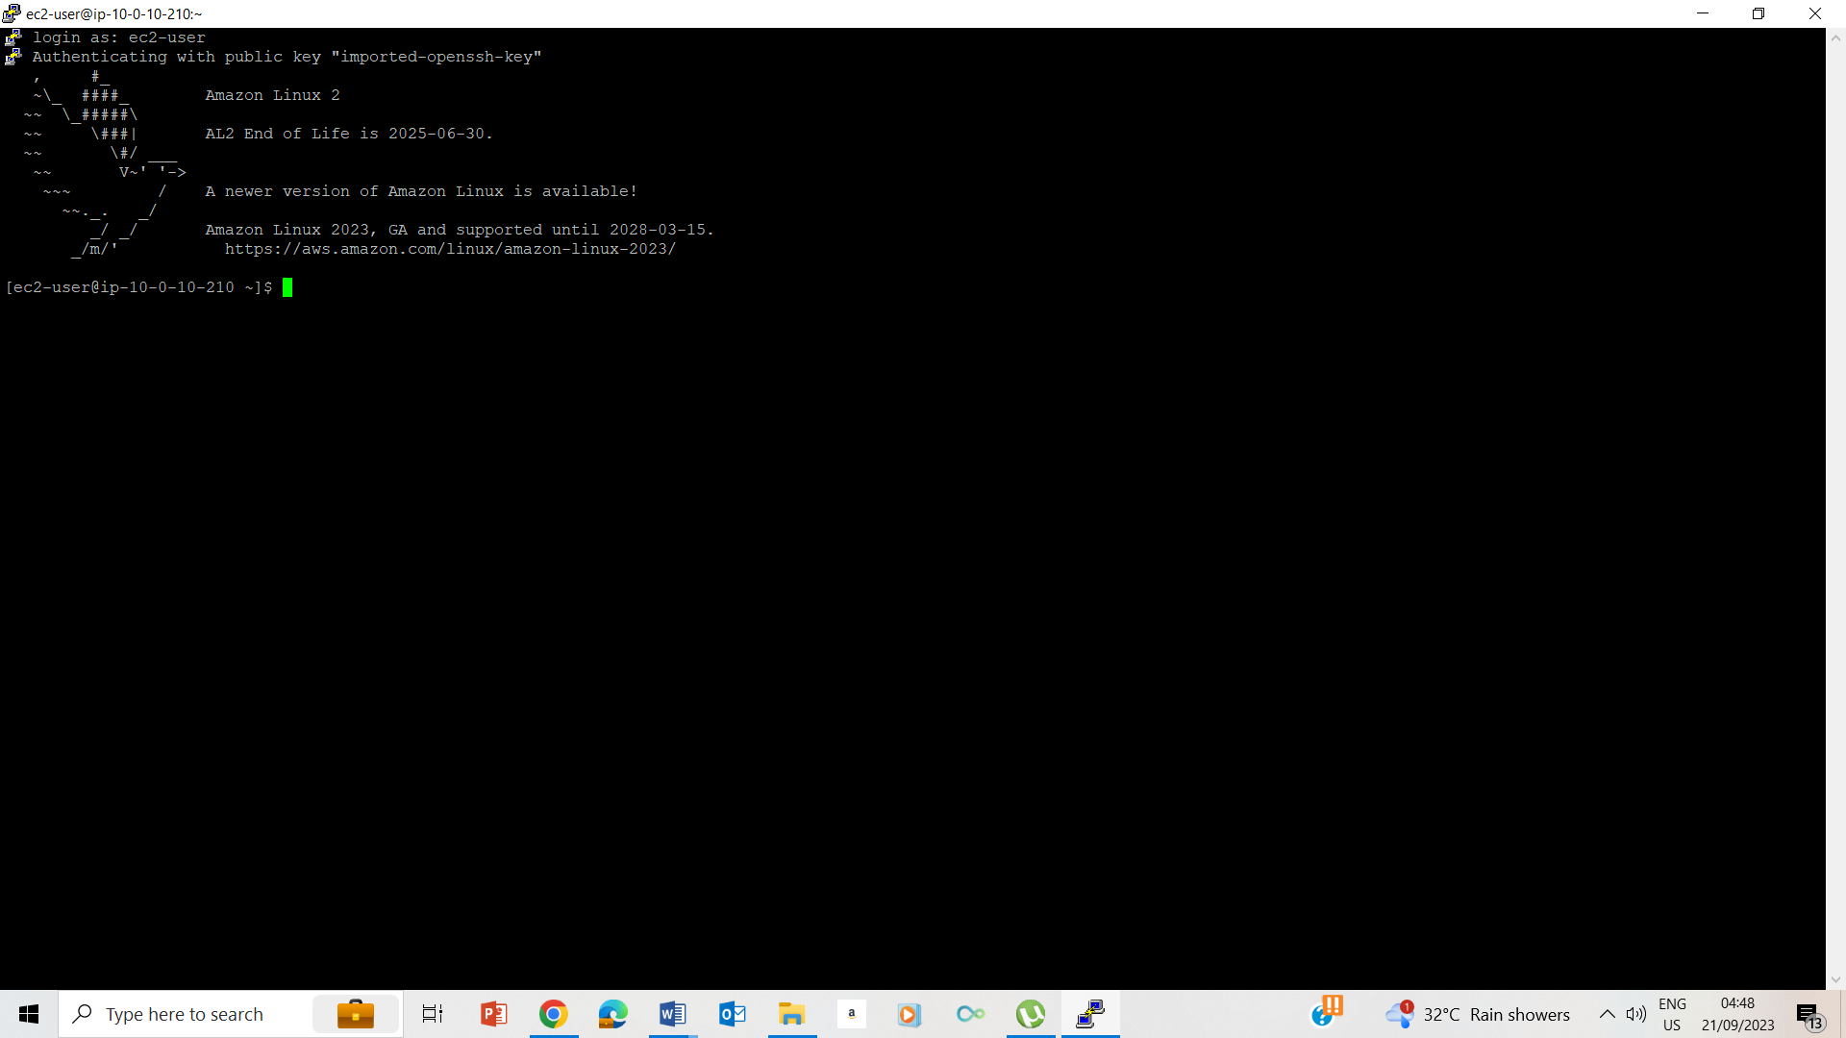

10-15. Configuring the putty

## Task 2: Write a shell script

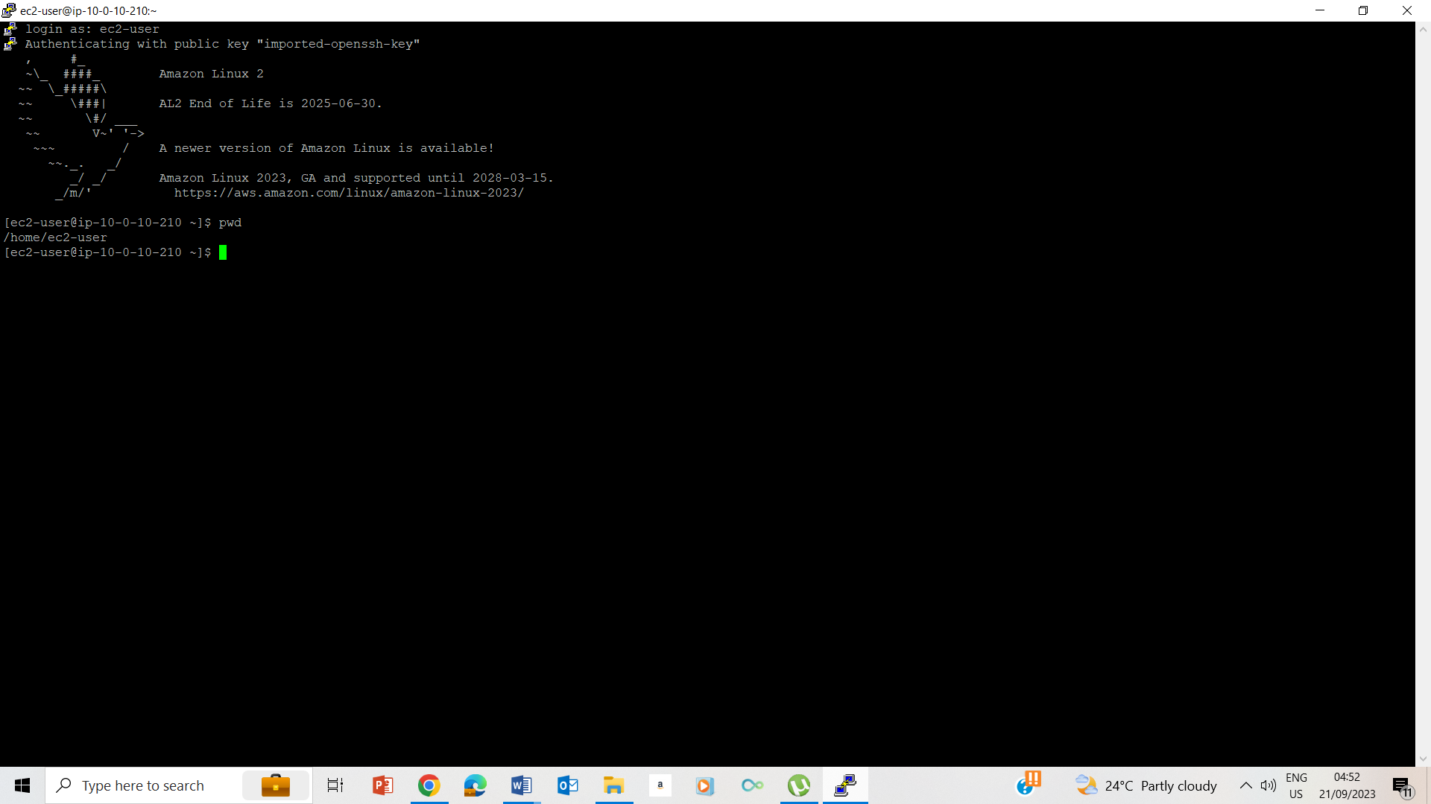

24. Validating that I am on the home folder by typing pwd and pressing enter

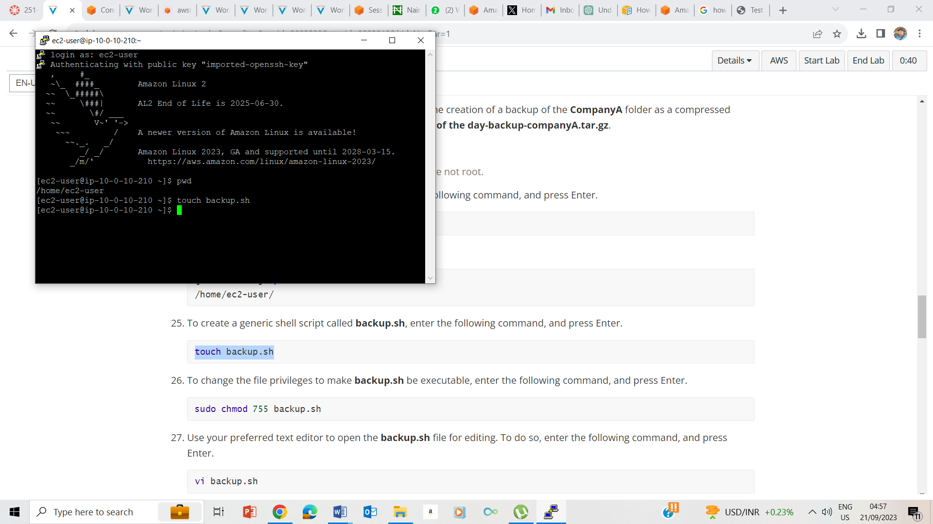

25. Created a generic shell script called backup.sh

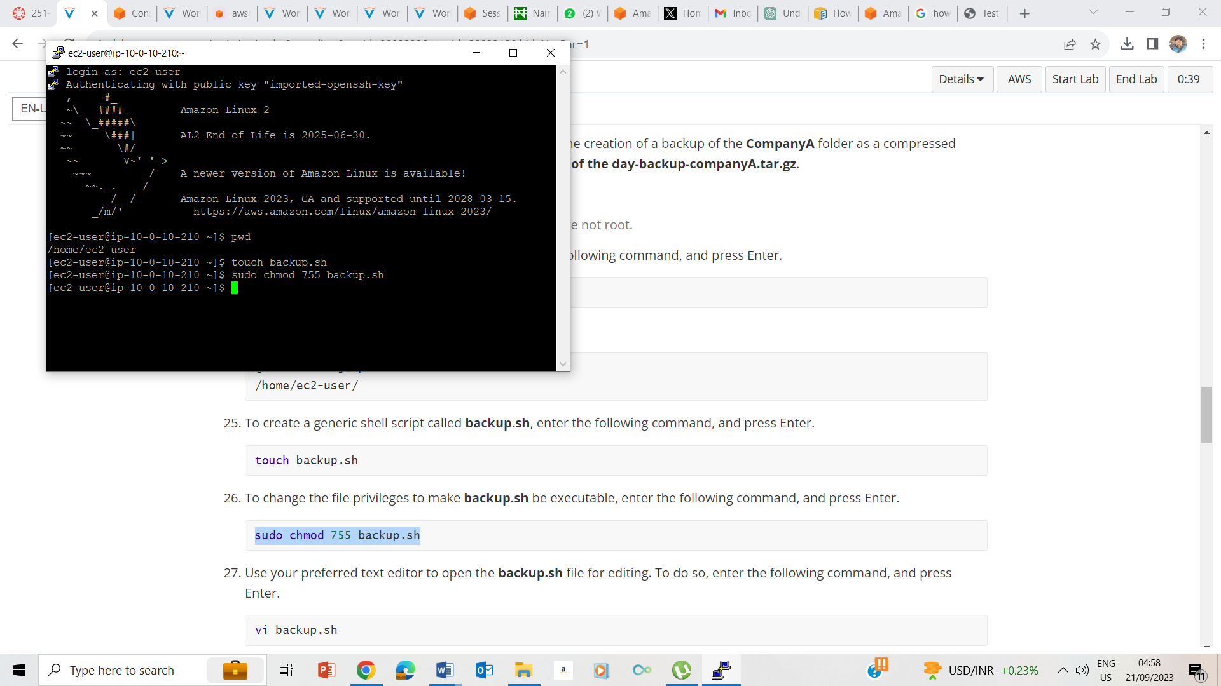26. Changed privileges to backup.sh

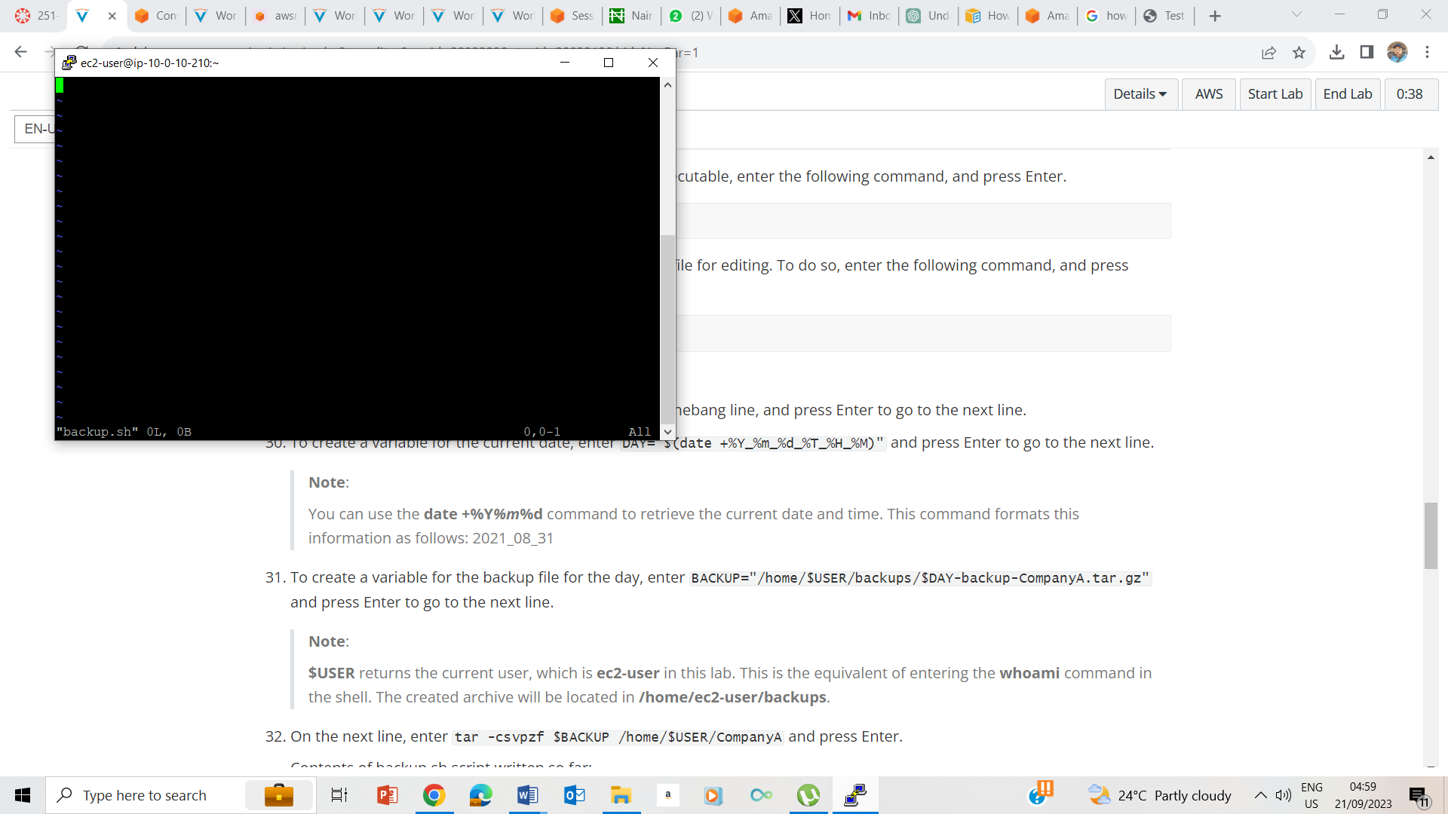

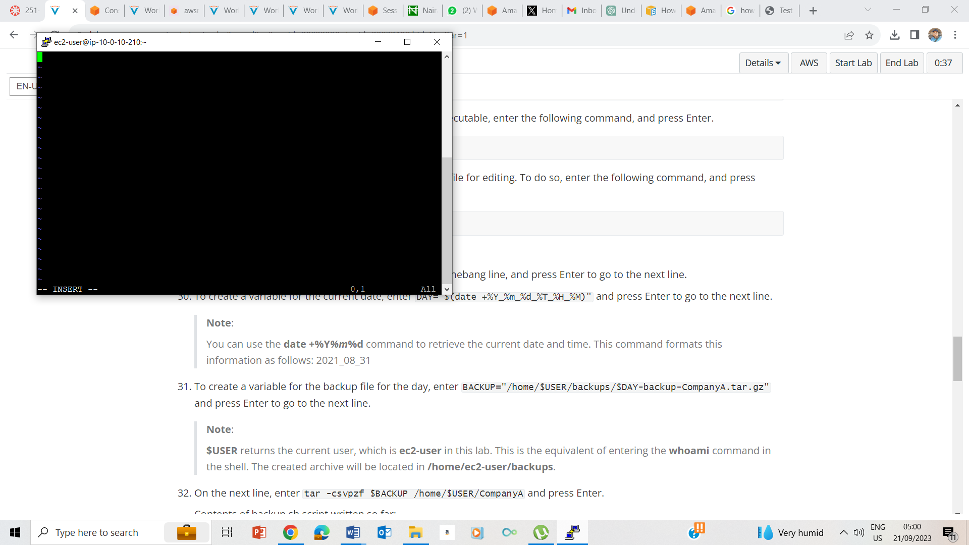

27-28. I used vi backup.sh and entered the insert mode by typing ‘I’ and pressing enter.

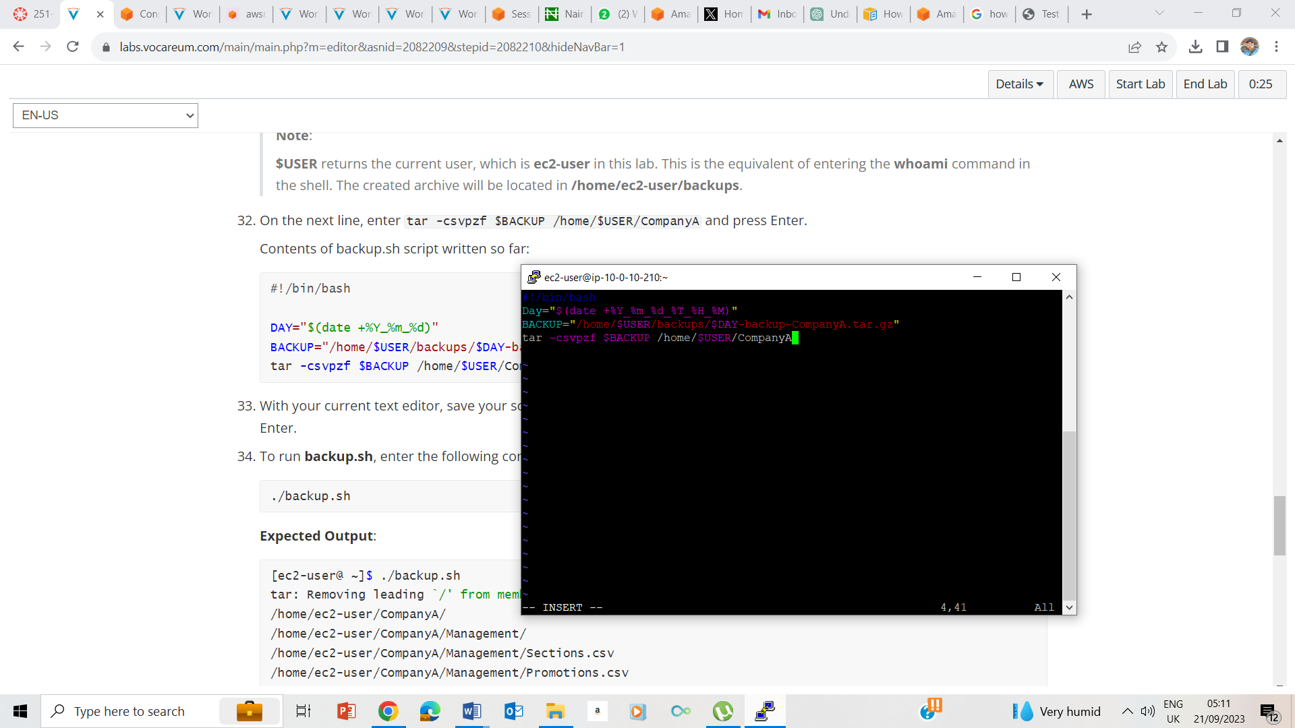

27-31. Entering the scripts.

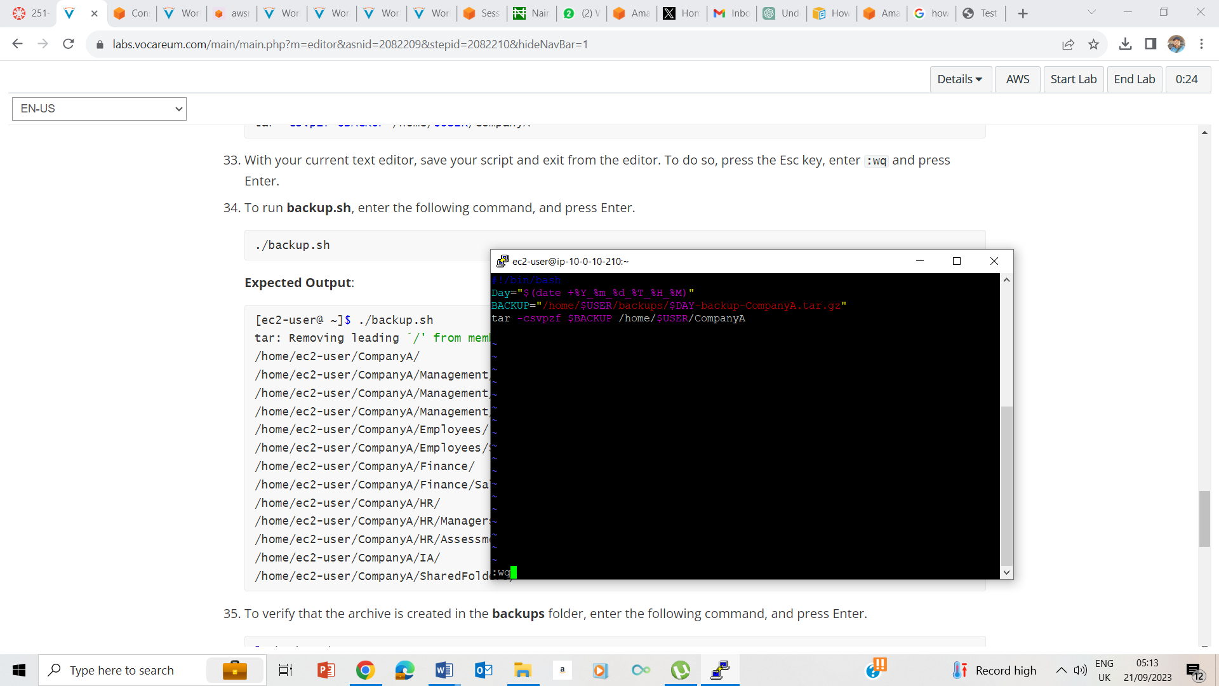

33. I pressed Esc key and :wq to save and quit.

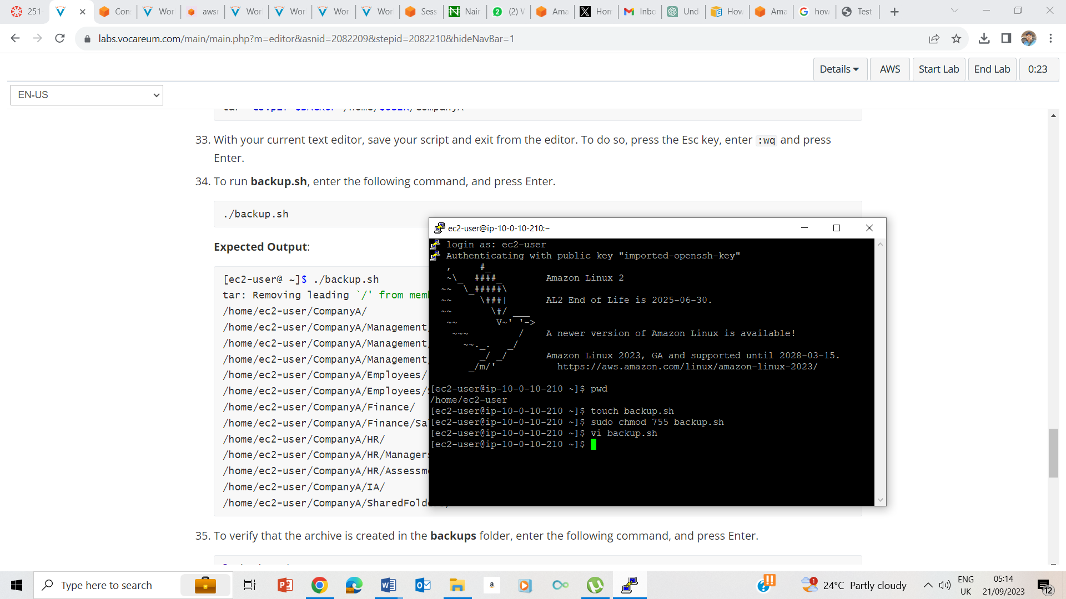

34. running the backup.sh

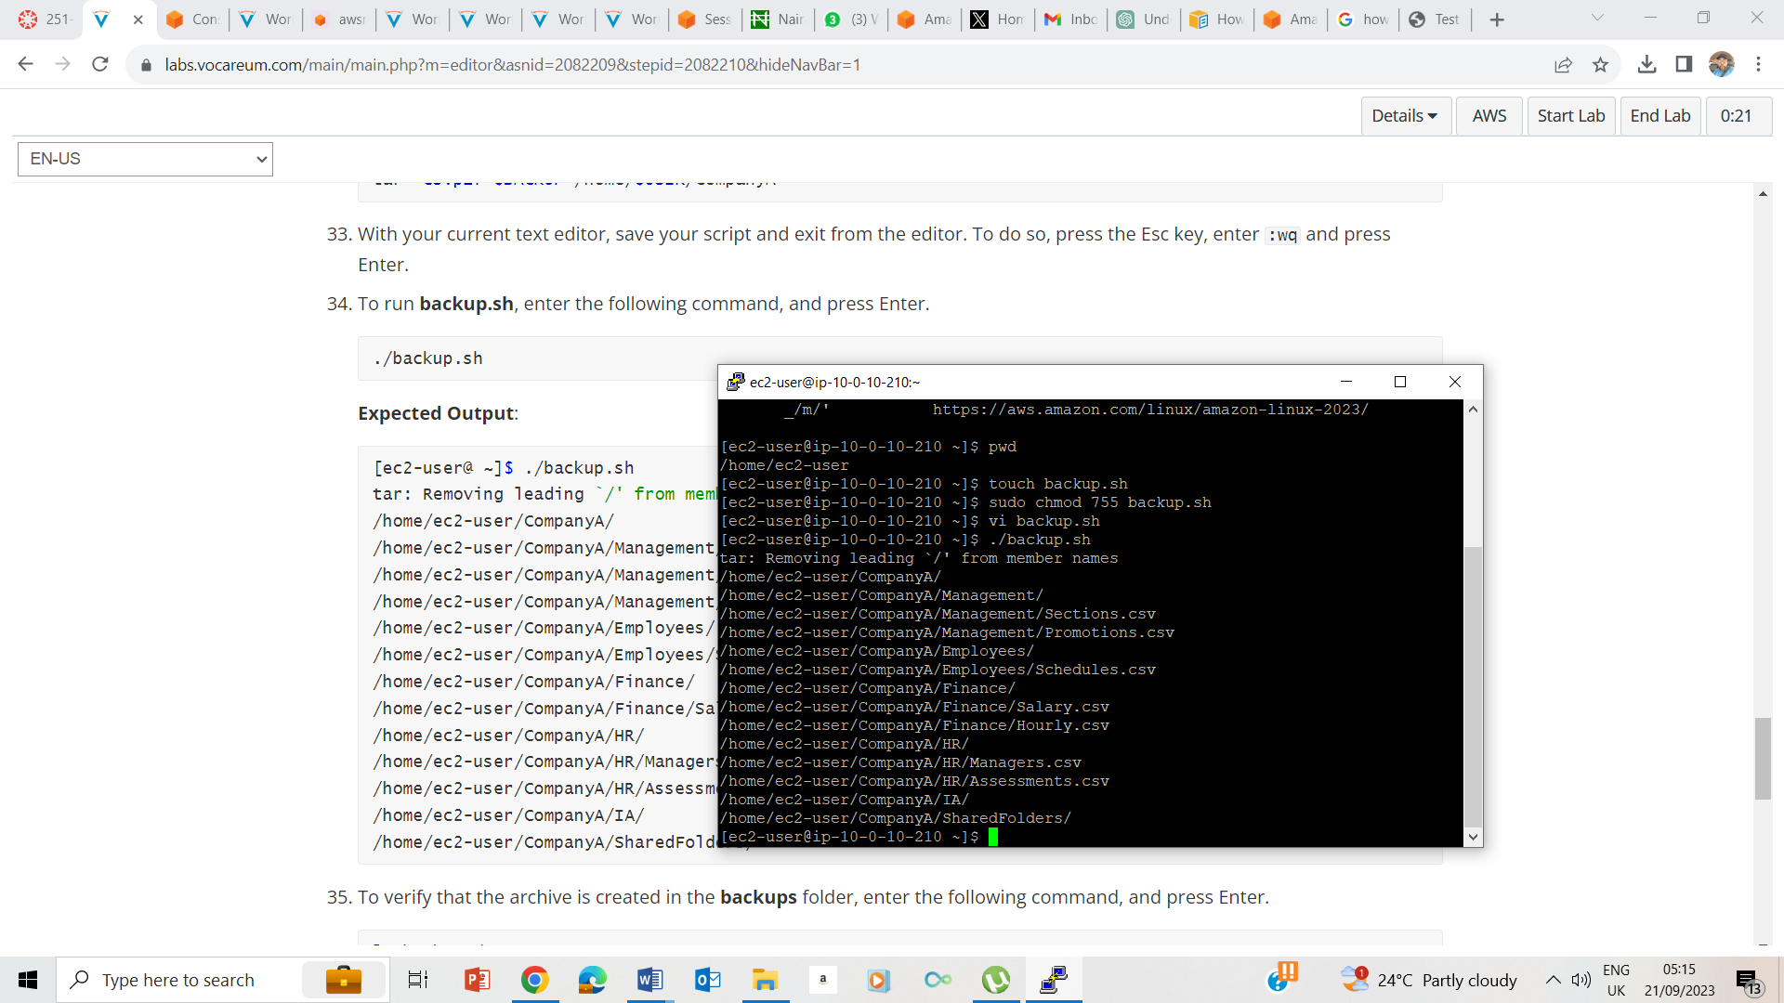

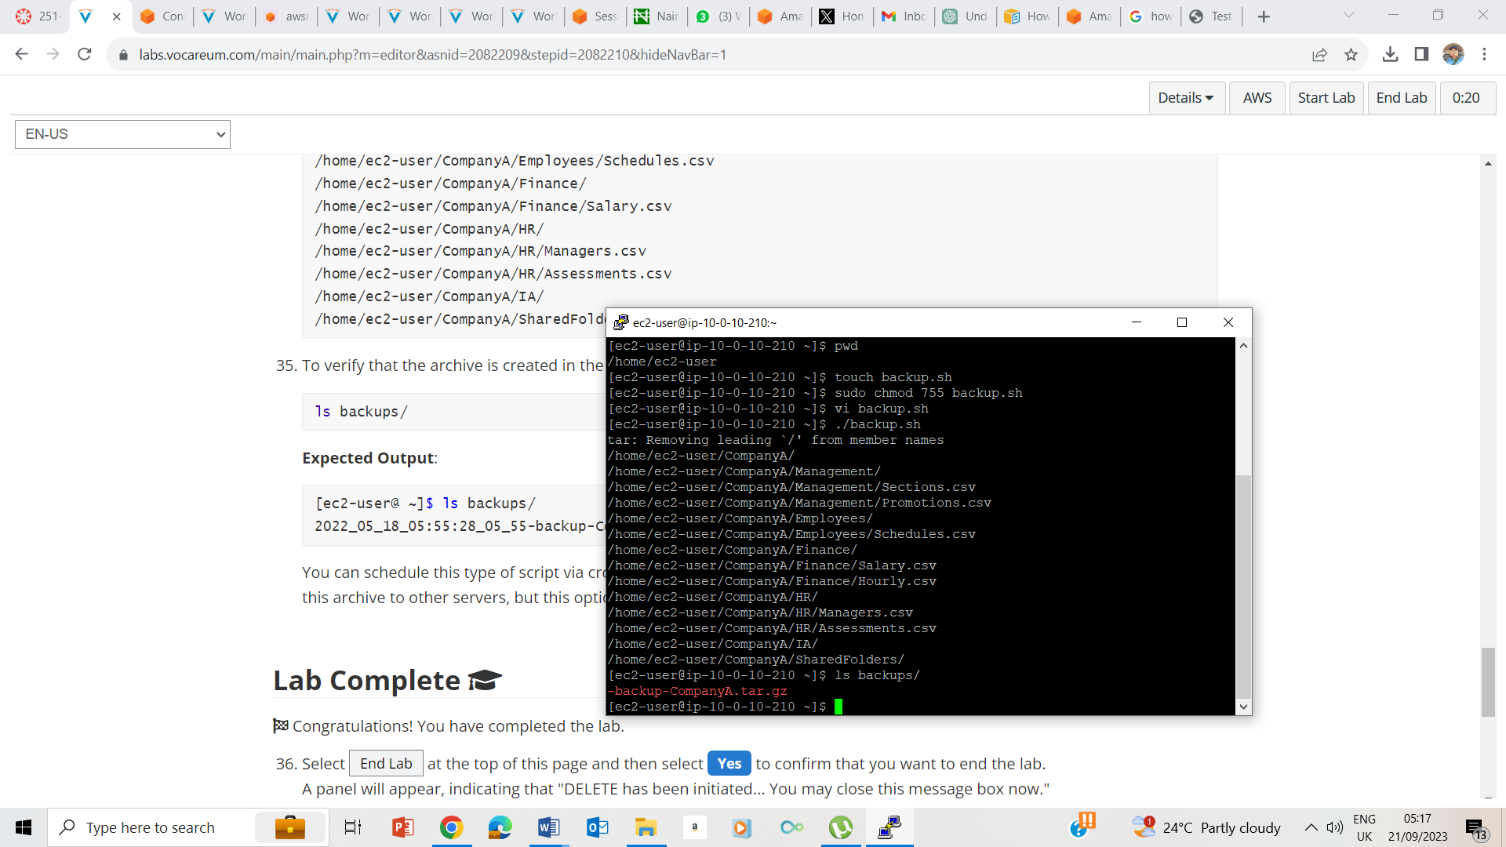

35. Verifying the archive by ls backups/

## Lab Complete

